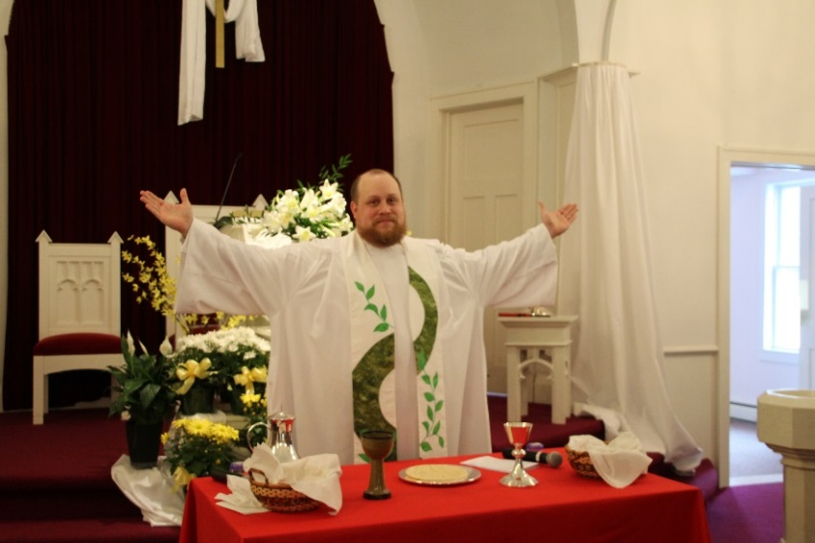

The PNC is pleased to recommend Rev. Kyle Delhagen to the congregation as our next pastor.
Come meet Pastor Kyle and his family on Saturday, September 10 from 3:00 to 5:00 in the fellowship hall.
Come to worship on September 11 and hear Pastor Kyle preach. Then the congregation will meet to vote on calling him to join us on our journey serving in the world as God leads us.

Kyle is both a traditional worship leader as well as a pastor that will add new elements to our services arising from being in touch with the community outside the church walls. He wants to actively engage with our music team and plan creative worship. He loves the idea of “worshipful work,” which is the idea that everything we do as a church community, from actual worship services to session and committee meetings, be done through the lens of worship.
His sermons are meaningful, well-shaped and thoughtfully delivered. The neutral pulpit sermon that was heard by the PNC was articulate, on-point and rather endearing. This is consistent with his sermons online.
In Kyle’s words, “Christian life and faith is expressed in community worship and service. Deuteronomy 11:18-19 says, ‘You shall put these words in your heart and soul… Teach them to your children, talking about them when you are home and when you are away, when you lie down and when you rise.’ We are called to live with the Word of God on our lips, but also in our every action. We are called to walk hand in hand with our brothers and sisters, serving those in need: the widow, the orphan, the immigrant, and so on. When we put our faith into action, coupled with worship and study of God’s word, we find the fullness of our life together.”
“I grew up the son of a minister, so we moved around a few times. However, I consider Pultneyville, New York to be home. It was in Pultneyville that my family--my Mom and Dad and my younger brother and sister and I--found a community that we would come to know as family. Pultneyville is a tiny hamlet of the town of Williamson, and most residents are related to someone else by blood or by marriage. Still, it was not long before I felt that I was a member of the family. “
As in the above paragraph, taken from his biography, Kyle wishes to establish relationships within our congregation. He wants to get to know each member of WPC, and not simply by name, but by knowing who they are, what they value, and what their hopes and dreams are. A pastor cannot effectively shepherd a worshipping community unless they are deeply invested in their people, and concurrently, a congregation must know, and be invested in, their pastor.
Kyle is the third generation in his family to serve as a pastor. His father Rev. Harold Delhagen is currently the Executive of the Synod of Northeast.
In his biography, Kyle shared this about his wife, Elena, “Finally, I would be remiss if I did not acknowledge how Elena has helped me to grow and stretch as a husband, as a pastor, and as a man. Her faith and strength has helped me to more clearly discern God’s call on my life, and together with her I found the joys of being a minister to God’s people. “
Elena and Kyle are coming to us from Philadelphia where both were teachers in a Christian school and Kyle served his first congregation. They will be bringing Atticus James who joined their family in person on July 27th.

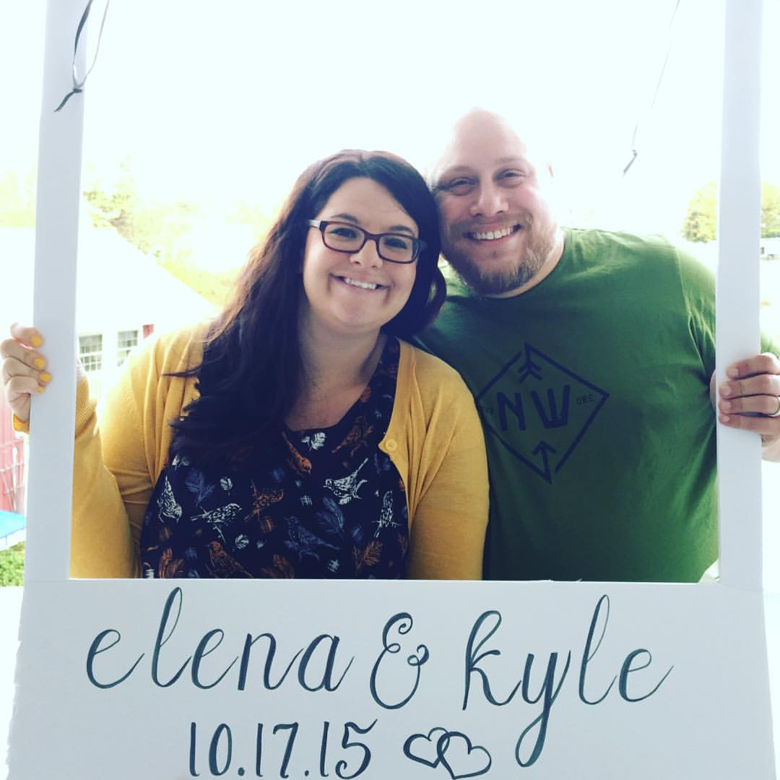
Atticus James Delhagen on July 27th.
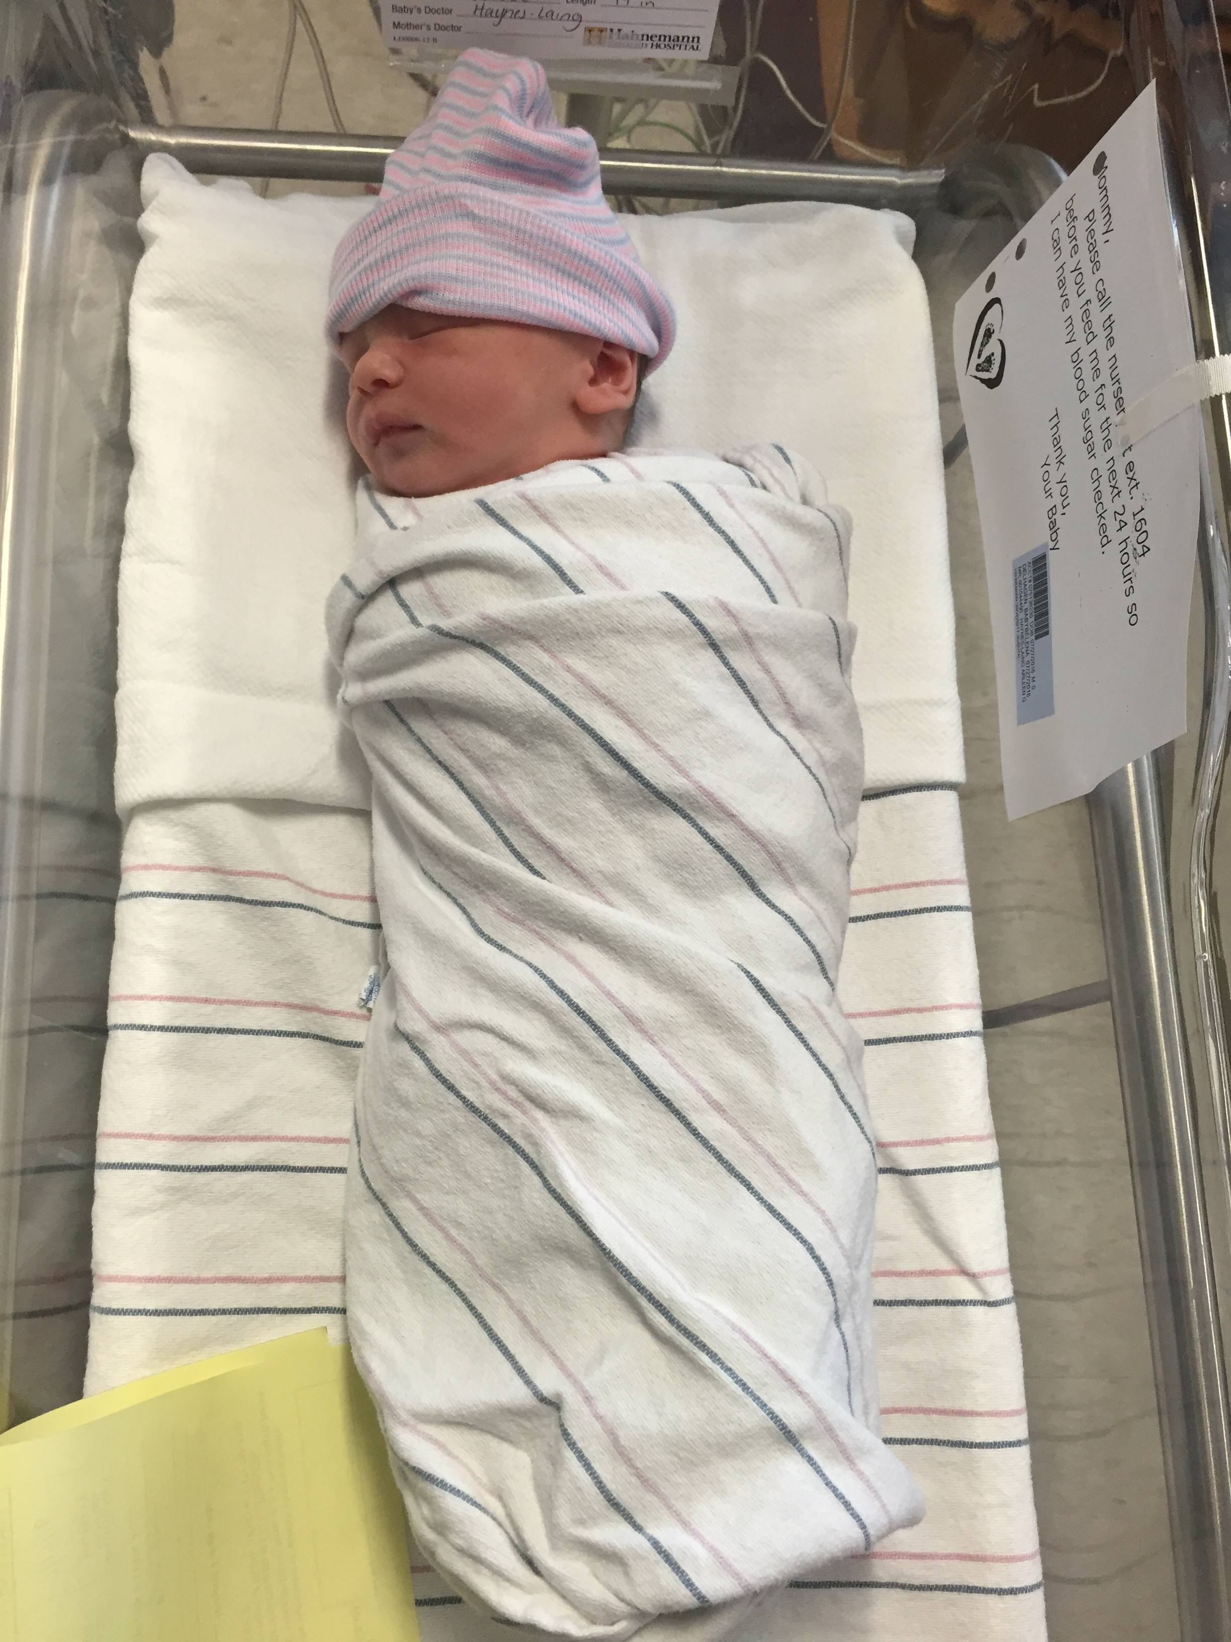

The PNC, unanimously, recommends calling Rev. Kyle Delhagen as pastor of WPC.
Kyle’s ordination is in the Reformed Church of America. Kyle is planning to change his ordination to the PCUSA after about 6 months, but because of the following agreement, being a pastor in the Reformed Church of America he is able to serve at Western Presbyterian.

In the Book of Order, Appendix B.* Official Text, “A Formula of Agreement between the Evangelical Lutheran Church in America, the Presbyterian Church (USA), the Reformed Church in America and the United Church of Christ. It has been declared that any of these institutions have come together and are in full communion with one another.”

Copies of Appendix B, as well as Kyle’s biography and statement of faith are available upon request.

